Fostering Internationalization at Montenegrin HEIs through
Efficient Strategic Planning - IESP
On-line Training on Summer Schools organized by the University of Ljubljana
22, 23 October 2020

List of participants from the University of Montenegro
Faculty of Economics training
Name | position | e-mail
dr Milena Radonjić |  | milena.ra@ac.me
dr Ivan Radević |  | ivan@radevic.me
dr Julija Cerović Smolović |  | julija@ucg.ac.me
dr Ana Mugoša | Teaching Associate  https://www.ucg.ac.me/radnik/110088-ana-mugosa | ana.mugosa@ucg.ac.me
mr Milica Vukčević |  | milica.v080@gmail.com
mr Dragana Ćirović | Teaching Associate  https://www.ucg.ac.me/radnik/900590-dragana-cirovic | gagacirovic93@gmail.com
mr Milica Muhadinović | Teaching Associate  https://www.ucg.ac.me/radnik/900203-milica-muhadinovic | milicamuhadinovic@gmail.com
mr Bojan Pejović |  | bojan.p@ucg.ac.me
mr Sunčica Rogić | Teaching Associate  https://www.ucg.ac.me/radnik/900216-suncica-rogic | suncica.rogic@hotmail.com
mr Magdalena Đurašković | PR office | magdalena@ucg.ac.me
Nemanja Đurišić | Administrative staff | nemanja.djurisic89@gmail.com
Slavica Vučković | Vice-dean for International Cooperation, Faculty of Architecture  https://www.ucg.ac.me/radnik/300218-slavica-stamatovic-vuckovic | slavicas@t-com.me
Biljana Šćepanović | Vice-dean for International Cooperation, Faculty of Civil Engineering  https://www.ucg.ac.me/radnik/160302-biljana-scepanovic | biljazs38@gmail.com
Olga Pelcer Vujačić | Vice-dean for International Cooperation, Institute for History  https://www.ucg.ac.me/radnik/900226-olga-pelcer-vujacic | olgapelcer@gmail.com
Andrej Perović | Faculty of Mathematics and Natural Sciences  https://www.ucg.ac.me/radnik/170594-andrej-perovic | perovic.an@gmail.com
Bozidar Popovic | Faculty of Mathematics and Natural Sciences  https://www.ucg.ac.me/radnik/196130-bozidar-popovic | bozidarp@ucg.ac.me
Spomenka Delibašić | Vice-dean for International Cooperation, Faculty of Filology  https://www.ucg.ac.me/radnik/195957-spomenka-delibasic | spomenkad@ucg.ac.me

Faculty of Maritime Studies training
Name | position | e-mail
Prof. danilo Nikolić | Rector  https://www.ucg.ac.me/radnik/230160-danilo-nikolic | dannikol@t-com.me
Prof. Špiro Ivošević | Dean  https://www.ucg.ac.me/radnik/235152-spiro-ivosevic | spiroi@ucg.ac.me
Tatjana Dlabač | Vice-dean for Science  https://www.ucg.ac.me/radnik/230290-tatijana-dlabac | tanjav@ucg.ac.me
Prof. Senka Šekularac Ivošević | Vice-dean for International Cooperation  https://www.ucg.ac.me/radnik/230333-senka-sekularac-ivosevic | saradnja.pfk@ucg.ac.me
Milena Dževeradanović Pejović | Associate Professor  https://www.ucg.ac.me/radnik/230418-milena-dzeverdanovic-pejovic | milenadz@ucg.ac.me
Zorica Đurović | Teaching Associate  https://www.ucg.ac.me/radnik/230014-zorica-durovic | zoricag@ucg.ac.me
Radmila Gagić | Teaching Associate  https://www.ucg.ac.me/radnik/235254-radmila-gagic | radmilag@ucg.ac.me
Maja Škurić | Associate for Life-long Learning  https://www.ucg.ac.me/radnik/230056 | majask@t-com.me

Faculty of Law training
Name | position
Vladimir Savković | Vice-dean for International Cooperation  https://www.ucg.ac.me/radnik/120296-vladimir-savkovic | vsavkovic@t-com.me
Velibor Korać | Teaching Associate  https://www.ucg.ac.me/radnik/120124-velibor-korac | velibork@ucg.ac.me
Rajka Đoković |  | rajkadj rajkadj@ucg.ac.me
Marinaa Jovićević | Teaching Associate | marinajovicevic@gmail.com

Faculty of Fine Arts training
Name | position | e-mail
Maja Šofranac | Teaching Associate, Vice-dean for International cooperation  Faculty of Fine Arts  https://www.ucg.ac.me/radnik/245071-maja-sofranac | majasofranac@gmail.com
Lidija Nikčević | Faculty of Fine Arts  Teaching Associate  https://www.ucg.ac.me/radnik/900944-lidija-nikcevic | nikceviclidija@gmail.com
Jelena Mišeljić | Teaching Associate  https://www.ucg.ac.me/radnik/250209-jelena-miseljic | jelena.mi@ucg.ac.me
Bojan Martinović | Dean, Music Academy  https://www.ucg.ac.me/radnik/260358-bojan-martinovic | bojanmartinovic2@gmail.com
Tanja Krkeljić | Vice-dean for International Cooperation, Music Academy  https://www.ucg.ac.me/radnik/260172-tatjana-krkeljic | krkeljic7369@t-com.me
Vujadin Krivokapić | Vice-dean, Music Academy  https://www.ucg.ac.me/radnik/260055-vujadin-krivokapic | vujadinkrivokapic@gmail.com

UL School of Economics and Business, 22. 10. 2020, 8.30 – 10.15

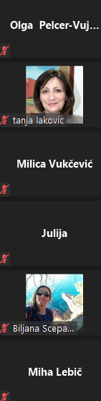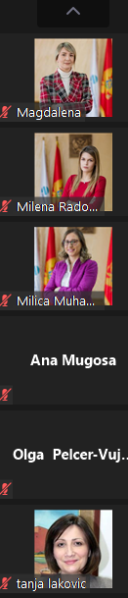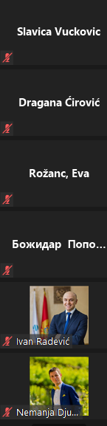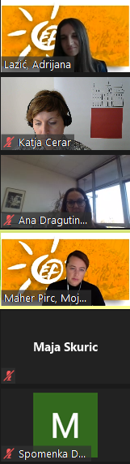

UL School of Economics and Business, 22. 10. 2020, 10.45 – 12.30
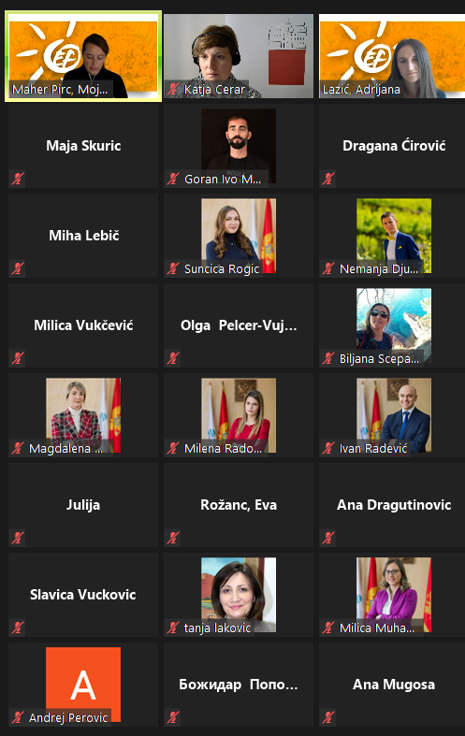

UL Faculty of Martime Studies and Transport, 22. 10. 2020, 14.00 – 16.00
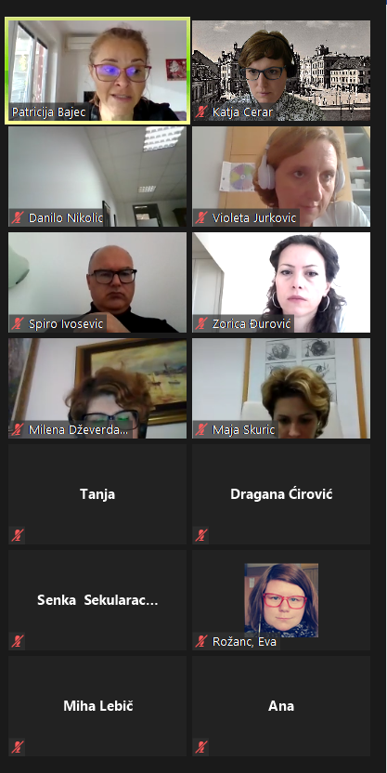
UL Academy of Fine Arts and Design, 23. 10. 2020, 9.30 – 11.10

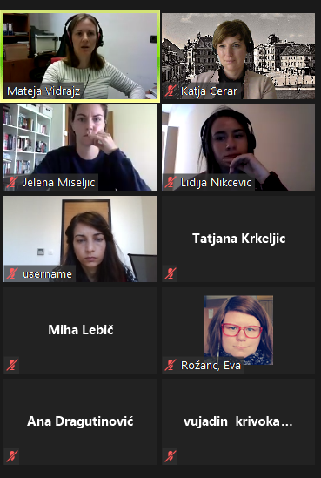

UL Academy of Fine Arts and Design, 23. 10. 2020, 12.00 – 13.30

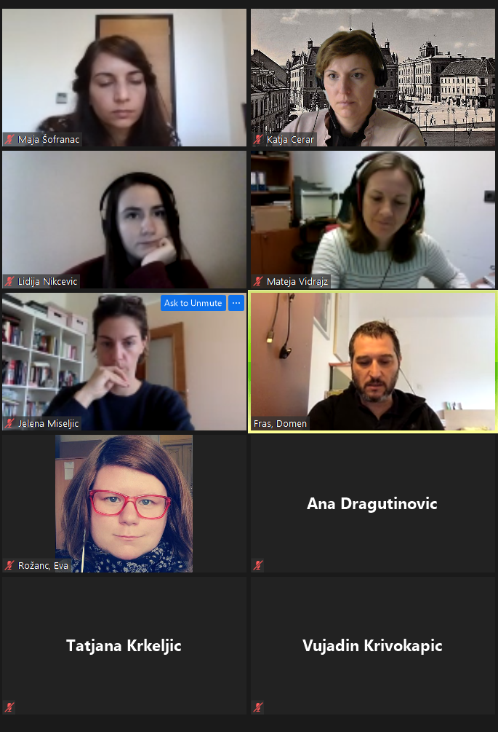

University of Ljubljana Faculty of Law, 23. 10. 2020, 14.30 – 15.30

