INFO ON THE “DIJAŠKI DOM PORTOROŽ” BOARDING SCHOOL AND HOSTEL
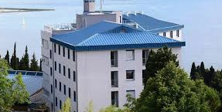
Location: Sončna pot 20, Portorož, Slovenia; approximately 1 km from the main bus station of Portorož
Website: https://dijaski.geps.si/dokumenti/
The hostel is located between Bernardin and Portorož, on the hill below Beli Križ, 1 km from the centre of Portorož. The nearest beach is just 250 m away.
The hostel features a restaurant and free WiFi. All rooms are simply furnished and offer a desk with a chair. Some have views of the sea. The rooms either have a private bathroom or offer access to a shared bathroom with a shower.
Room description and photos: https://dijaski.geps.si/hostel/opis-sob/
The guests can enjoy table tennis and play basketball at the on-site court for free. The meeting room, self-service laundry, and a fitness centre are also provided. Numerous bike trails can be found 1.5 km from the property. Cafes, restaurants and grocery shops are only 250 m away.
The central bus station of Portorož is 2 km away. There are no trains running to Portorož. The nearest train station is located in Koper, 14 km from the property. The nearest local bus stop is 250 m away. The closest international airport is Trieste International Airport, 80 km away.
By car you can easily reach the hostel through Portorož in the direction of Piran. Drive to the salt warehouse that you will see on your left if you follow the coastal road and turn right into the demanding ascent before the gas station Fizine. At the top of the ascent you will see our hostel, easily recognisable by the blue roof. Take the road on the right and park in our parking lot.
Parking: Free
The bus (e.g., from Ljubljana) will most likely leave you at the central station in Piran or Portorož. The easiest way is to call a taxi, but you can take a local bus to the bus stop Fizine, then walk up the demanding ascent at the Fizine gas station.
Check-in: Please report your approximate arrival time to patricija.bajec@fpp.uni-lj.si. Staff will be waiting for you.
Is the hostel closed at night? You can enter the hostel at all hours, but please mind that you are not allowed to make any noise between 22:00 and 6:00.

Meals:
Breakfast: 6:30 – 8:00
Lunch: 12:00 – 15:00 (during the week)
Dinner: 18:00 – 19:00

Towels: Bring your own
Bed linen: provided

INFORMATION ON PORTOROŽ AND SURROUNDINGS

Things to do in Portorož and its surroundings/Transport/Food/Weather: https://www.portoroz.si/en/home

THE NEAREST AIRPORTS

Trieste (Italy): 80 km (https://triesteairport.it/en)
Venice Marco Polo (Italy): 190 km (https://www.veniceairport.it/en/)
Jože Pučnik Ljubljana (Slovenia): 140 km (https://www.fraport-slovenija.si)

Airport Transfers: https://www.goopti.com/en/

MAIN BUS STATION AND STOPS IN PORTOROŽ
https://getbybus.com/en/bus-from-portoroz

Main bus station is located 1,5 km from the students home, which is 20 min walk (see the picture below) and 7 min by local bus (https://www.portoroz.si/en/plan-your-stay/be-mobile-around-the-town/public-transport, https://arriva.si) or taxi
(https://www.portoroz.si/si/nacrtuj/prevozi-na-destinaciji/taxi-sluzbe (the list of taxis, including telephone numbers).

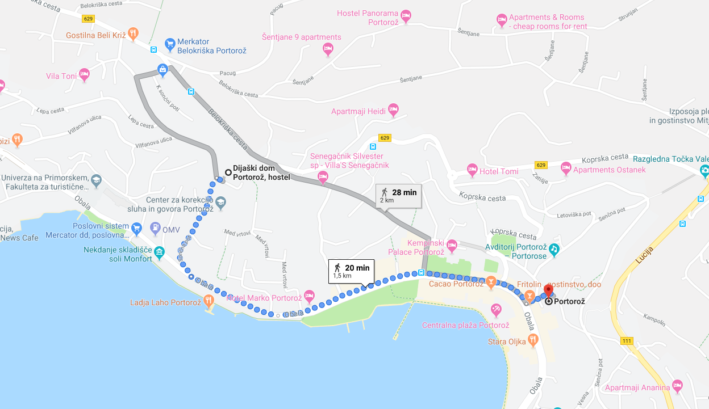

INFORMATION ON THE FACULTY OF MARITIME STUDIES AND TRANSPORT, PORTOROŽ (FPP)
Website: https://www.fpp.uni-lj.si/

Location: Pot pomorščakov 4, 6320 Portorož
https://www.google.com/maps/place/Univerza+v+Ljubljani,+fakulteta+za+pomorstvo+in+promet/@45.5161413,13.5776917,15z/data=!4m5!3m4!1s0x0:0xf2d6618629ceef5!8m2!3d45.5161413!4d13.5776917

Distance from the faculty to the hostel (10-minute walk):

