Fostering Internationalization at Montenegrin HEIs through
Efficient Strategic Planning – IESP

Title of Work package | WP 2 Capacity Building For Internationalization Through Staff Training And Equipment Upgrade
Activity no. | DEV 2.1: Procurement of equipment for supporting internationalization
Title of outcome | Report on the procurement of equipment for supporting internationalization
Activity date | March - November 2020
Authors | Ana Dragutinović, Maja Škurić

The University of Montenegro (P9) as the coordinator was in charge of the joint equipment procurement. For this purpose, the coordinator carried out consultations with the Montenegrin university partners (University Donja Gorica – P7 and University Mediterranean – P8) to compile the final list of the equipment to be procured. After agreeing with the partners on the list of equipment, it was sent to the EACEA project officer for final approval. After receiving it, P7 and P8 have authorized P9 to initiate a joint public procurement procedure. The equipment was purchased in one tender procedure, according to the Partnership Agreements, the EACEA rules, IESP Handbook, and national procurement rules.
The tender for equipment procurement was published by the Public Procurement Office of the University of Montenegro on 4th May 2020. Two offers were received and the decision on the selection of the more favorable bid was made. Following this, one of the bidders filed a complaint against the decision, which is why the tender documentation was forwarded to the State Commission for Protection of Rights in Public Procurement Procedures for the final decision. After considering the submitted documents, the State Commission declared the procedure on the selection of a more favorable bidder null and instructed the University of Montenegro to conduct a new tendering procedure.
The new procedure has initiated on 21st August 2020.

Invitation Number 05/1-2-1-612 for Open Procedure published at:

http://portal.ujn.gov.me/delta2015/search/displayNotice.html?id=134047&type=InvitationPublicProcure

The tender documentation, the decision on the selection of the bidder made on 24th September 2020, and the contracts concluded for the purchase of the equipment (issued on 6th and 9th October 2020, respectively) can be found at the above link.
The supporting documents of the tendering procedure are kept in the project records according to the national legislation.

The supplier installed the first part of the equipment as follows:

University of Montenegro’s units:

Rectorate, address: Cetinjska 2, 81000 Podgorica,

Faculty of Philology, address: Danila Bojovića bb, 81400 Nikšić,

Faculty for Sport and Physical Education, address: Narodne omladine bb, 81400 Nikšić,

Faculty of Maritime Studies Kotor, address: Put I bokeljske brigade 44, 85330 Kotor,

Faculty of Tourism and Hotel Management, address: Stari grad 320, 85330 Kotor.

University Donja Gorica, address: Donja Gorica bb, 81000 Podgorica.

University Mediterranean, address: Josipa Broza bb, 81000 Podgorica.
University of Montenegro – Photos of the delivered and installed first part of the equipment
Rectorate

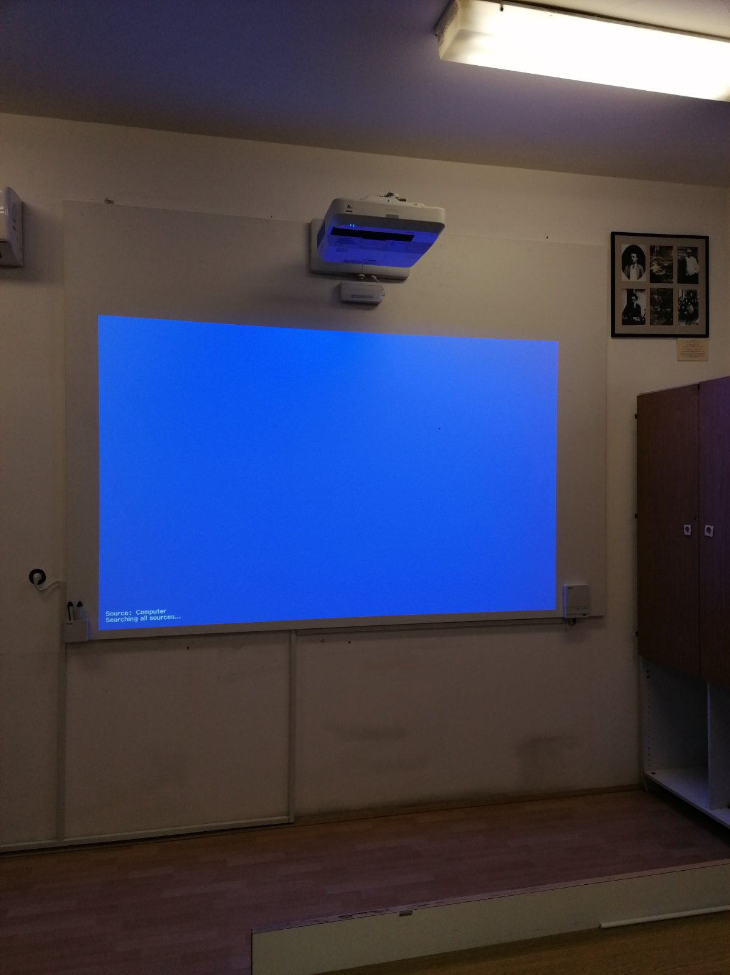 | 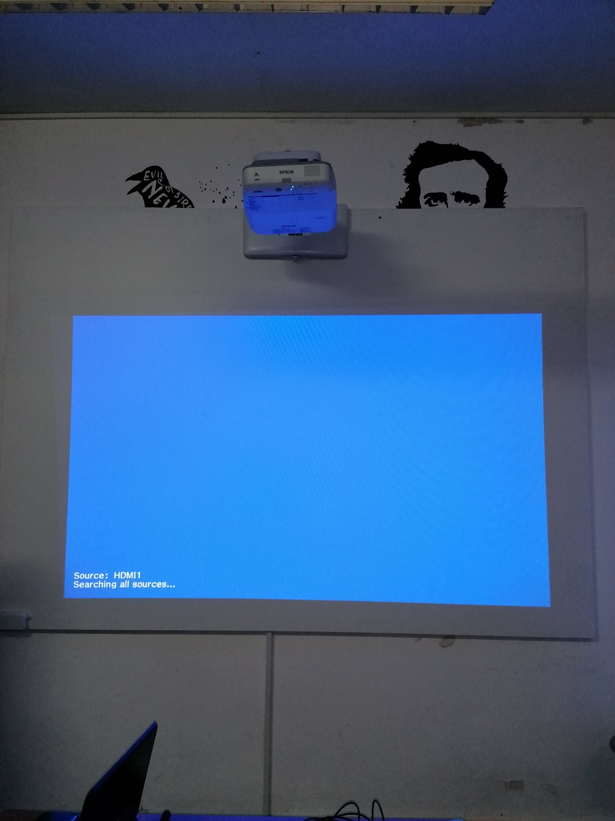
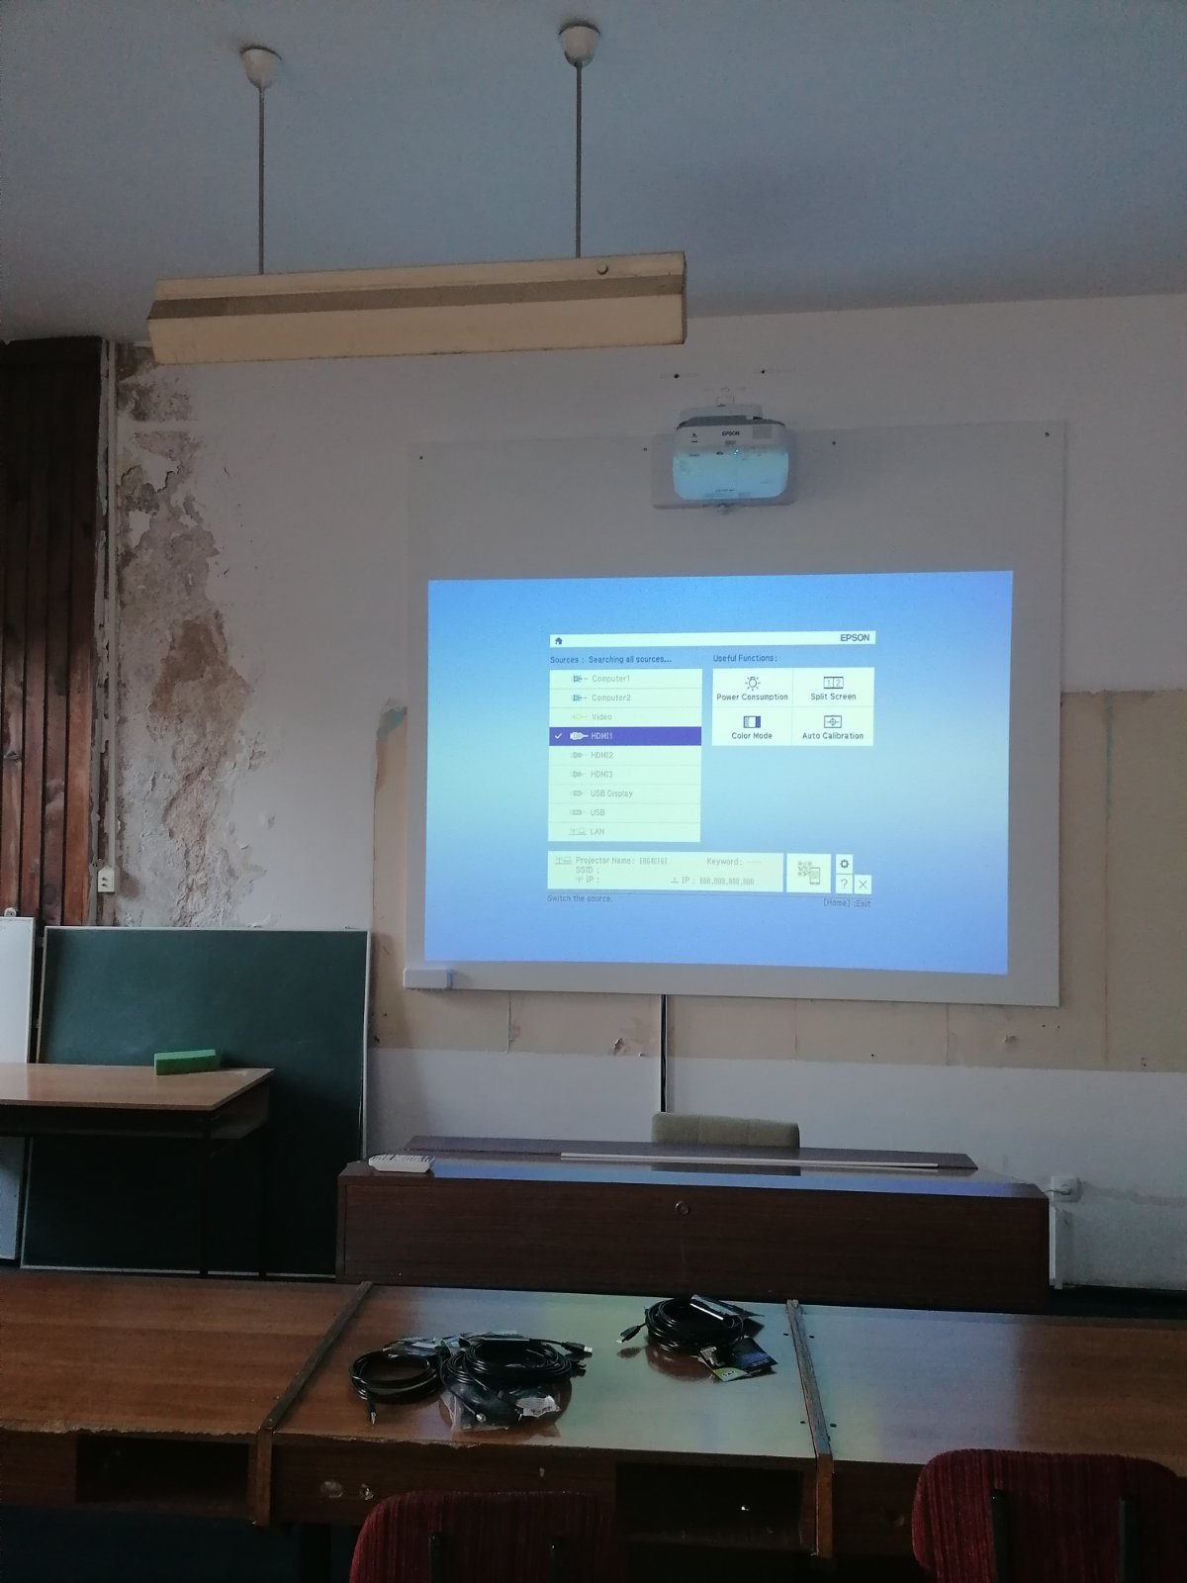
Faculty of Philology

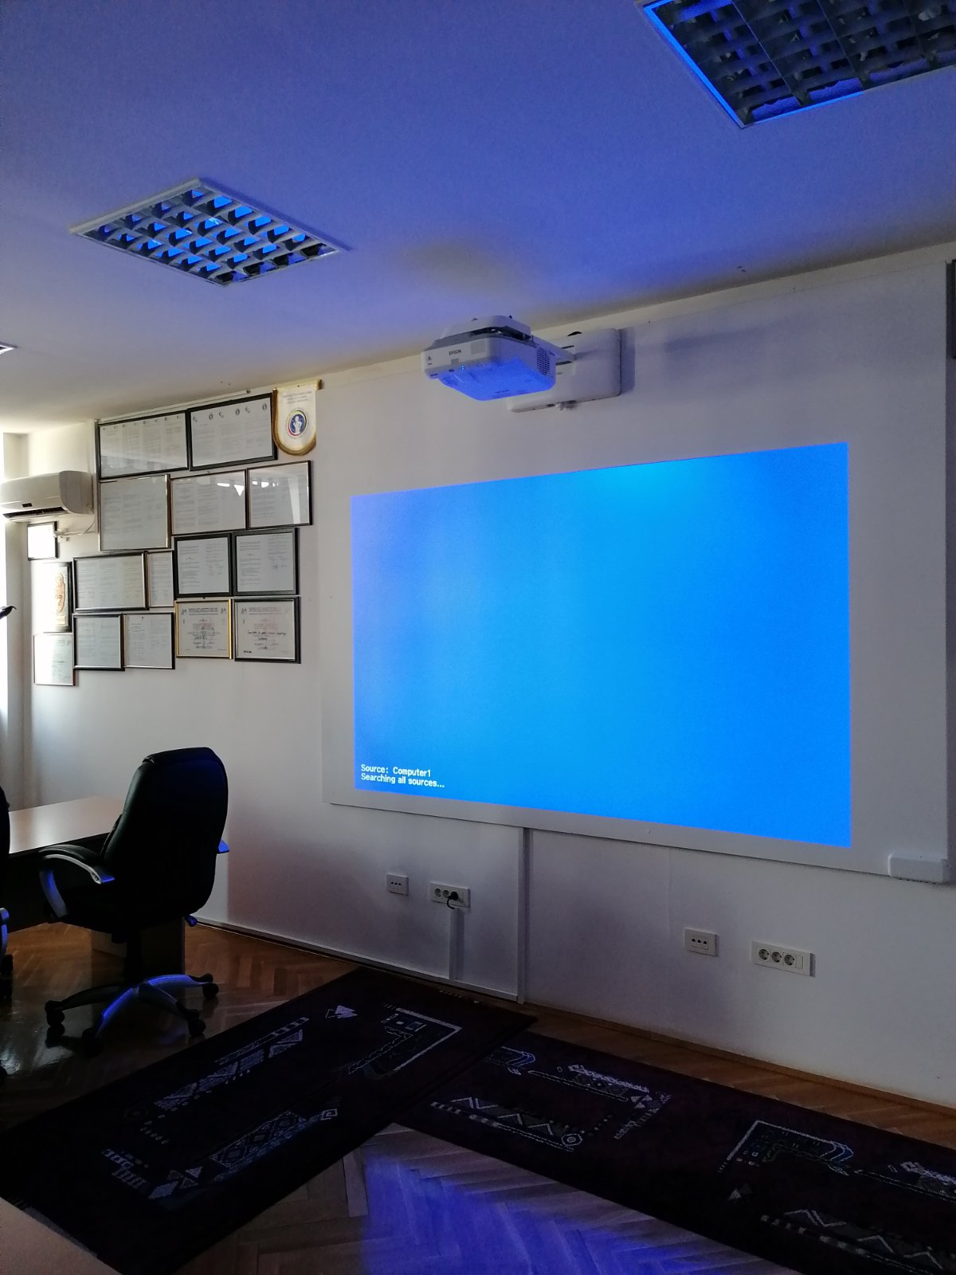 | 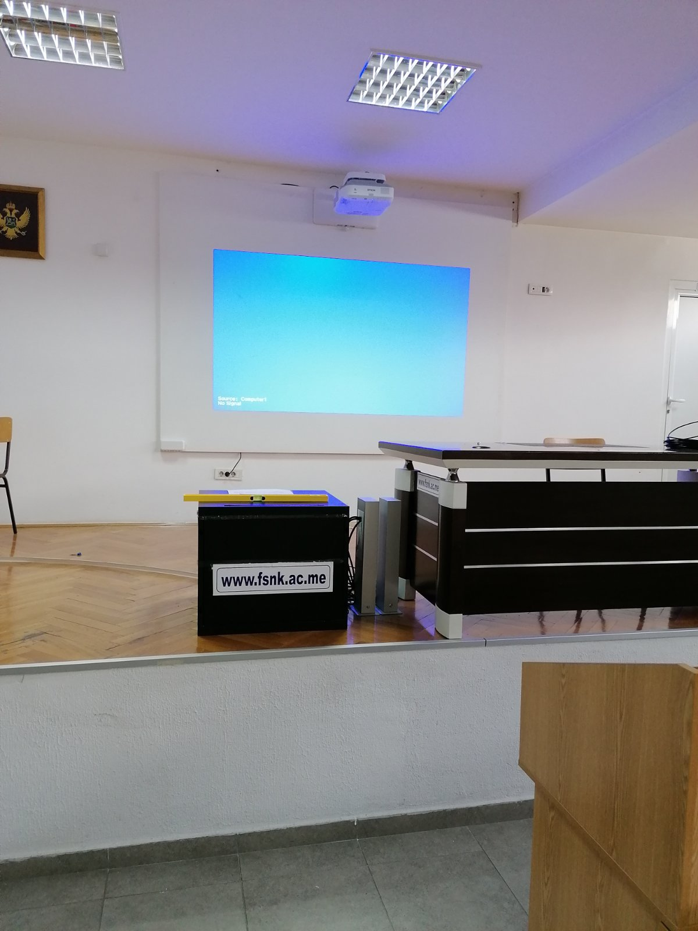
Faculty for Sport and Physical Education

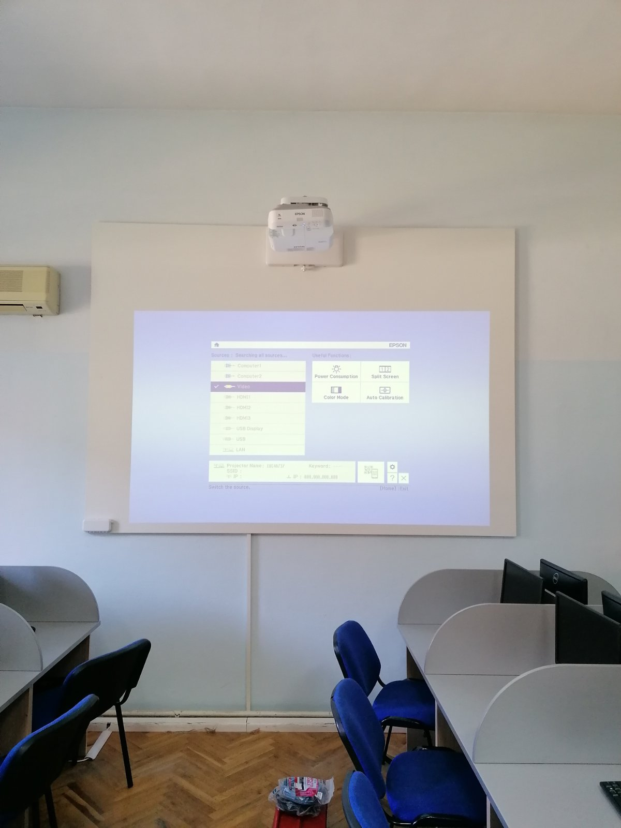 | 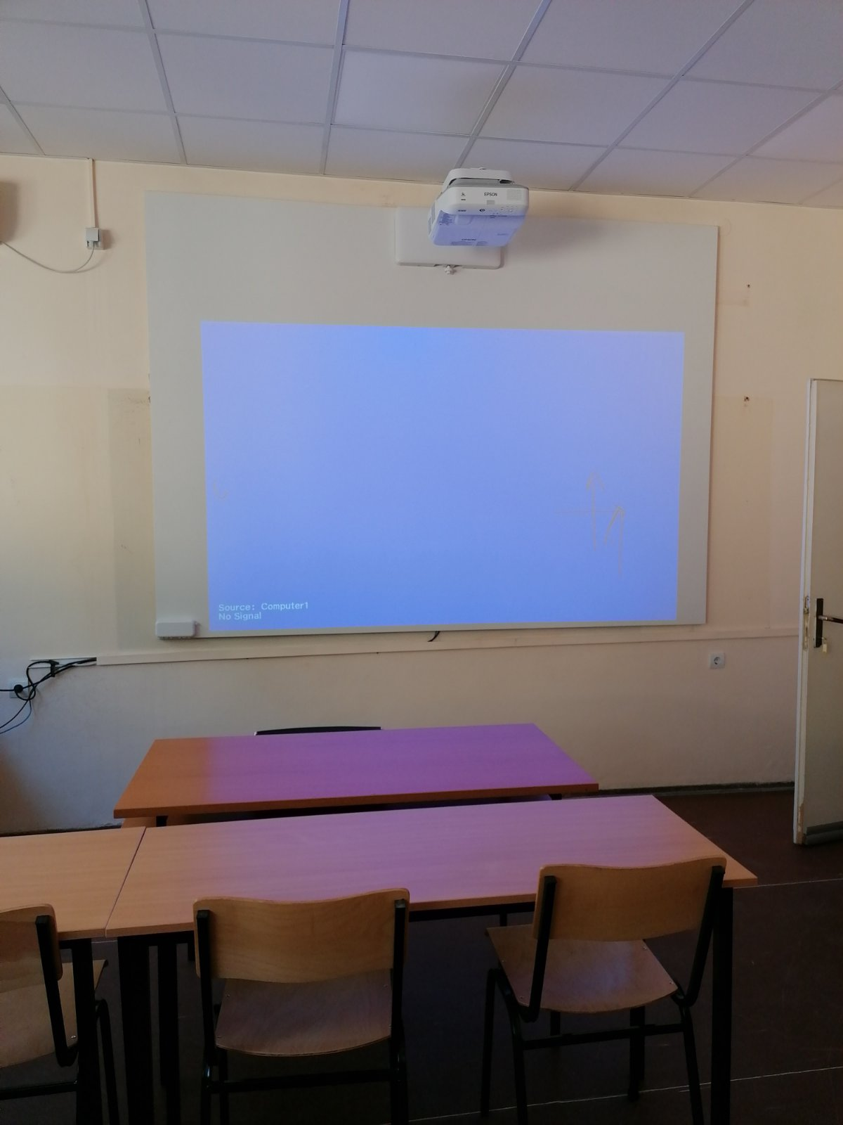
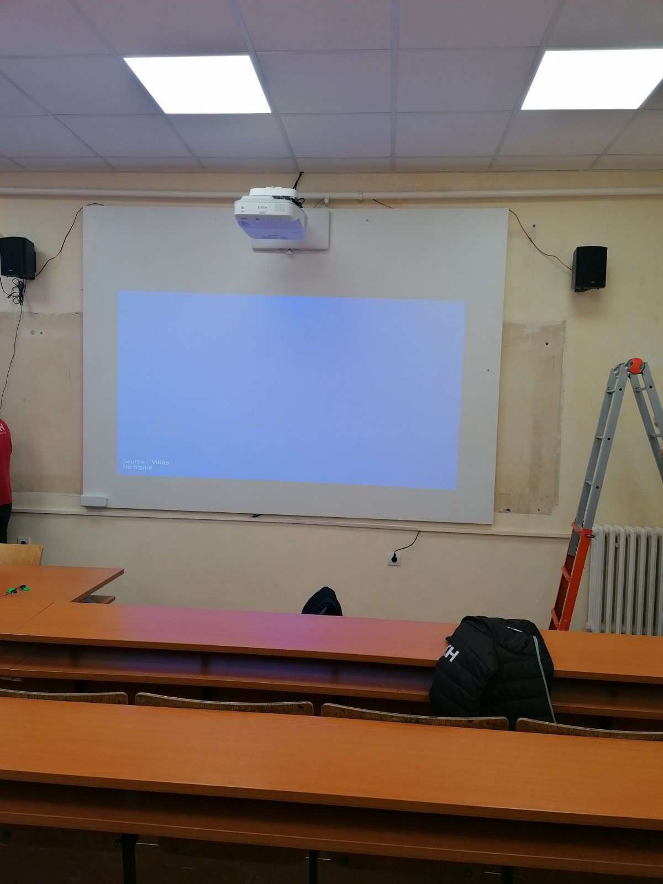
Faculty of Maritime Studies Kotor

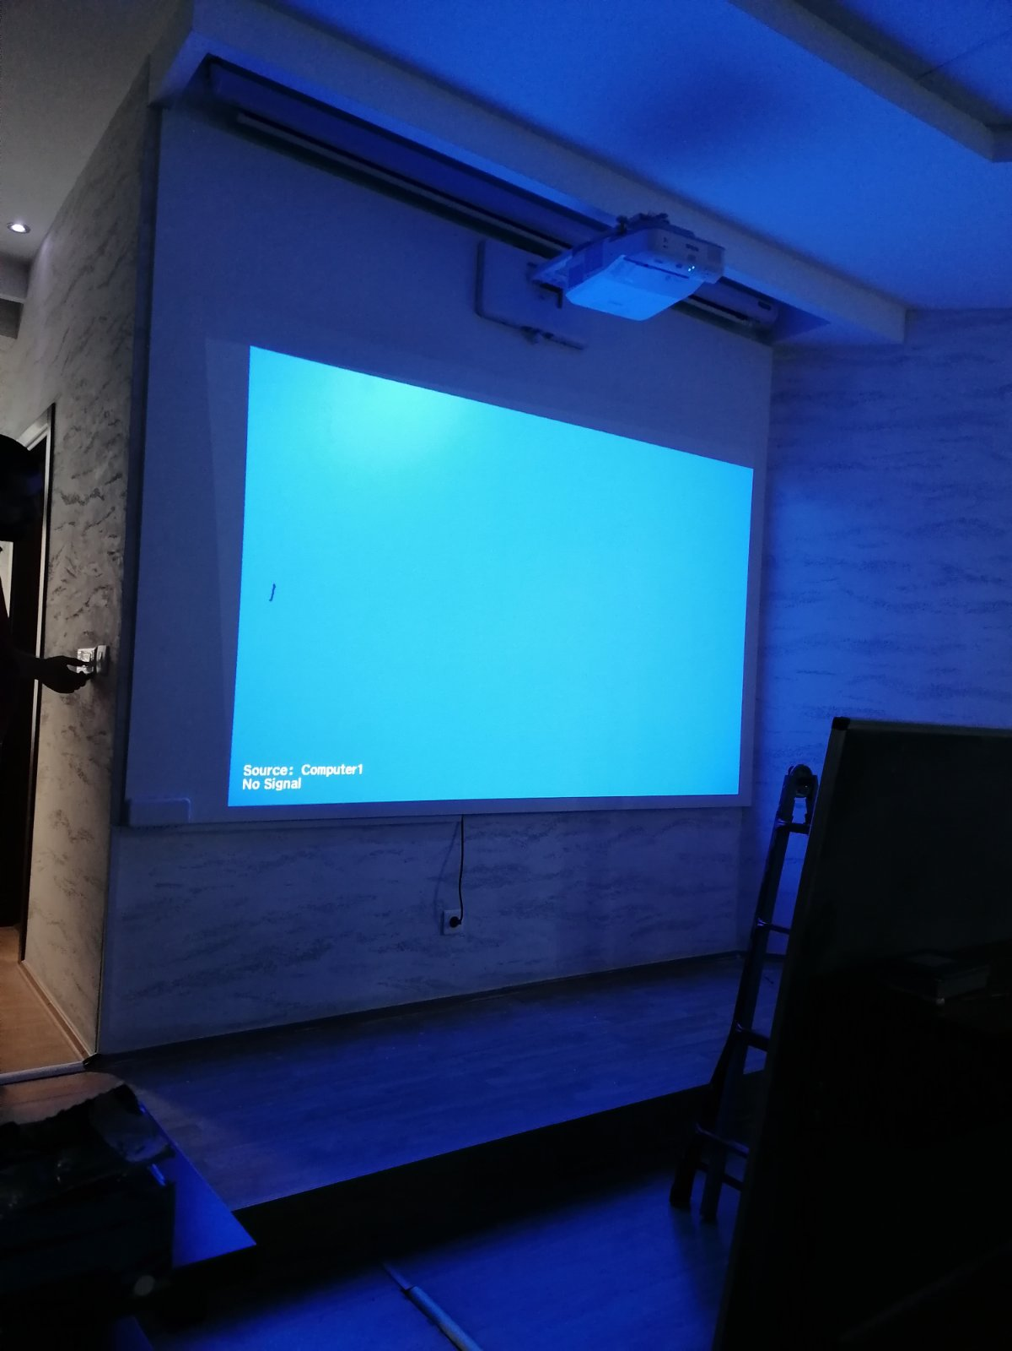 | Faculty of Tourism and Hotel Management

University Mediterranean – Photos of the delivered and installed first part of the equipment
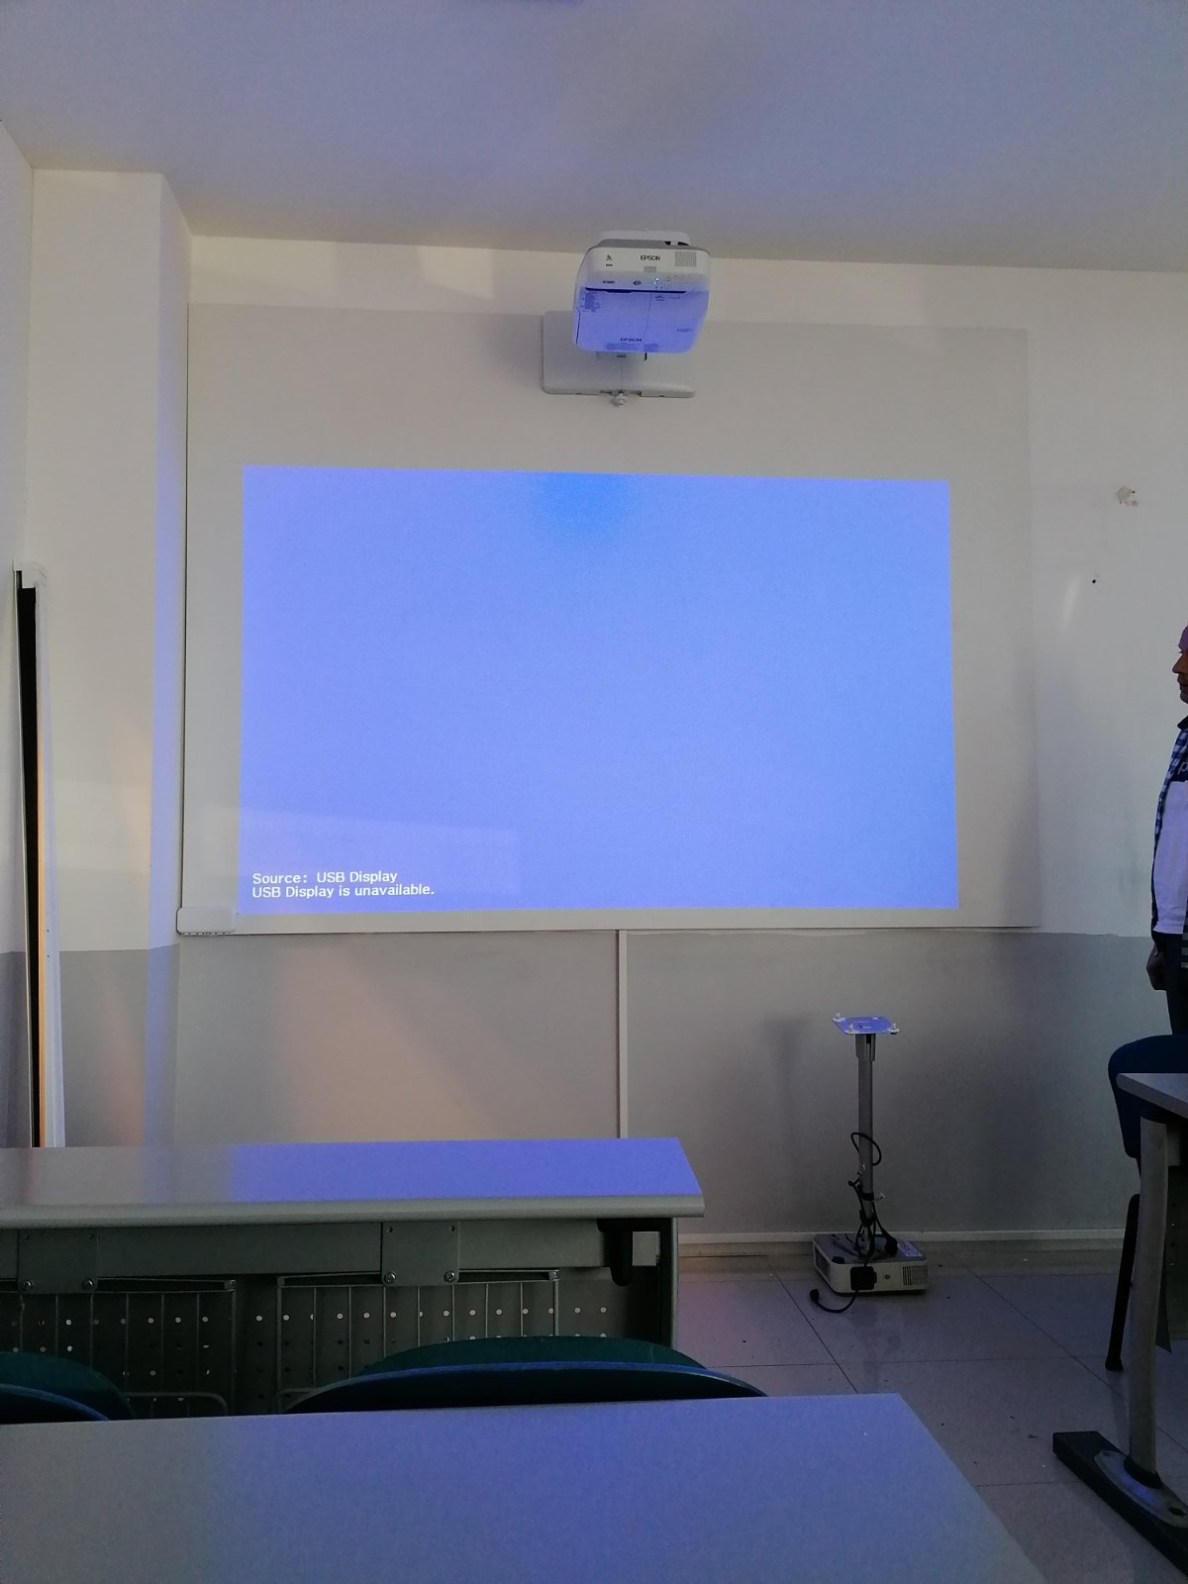 | 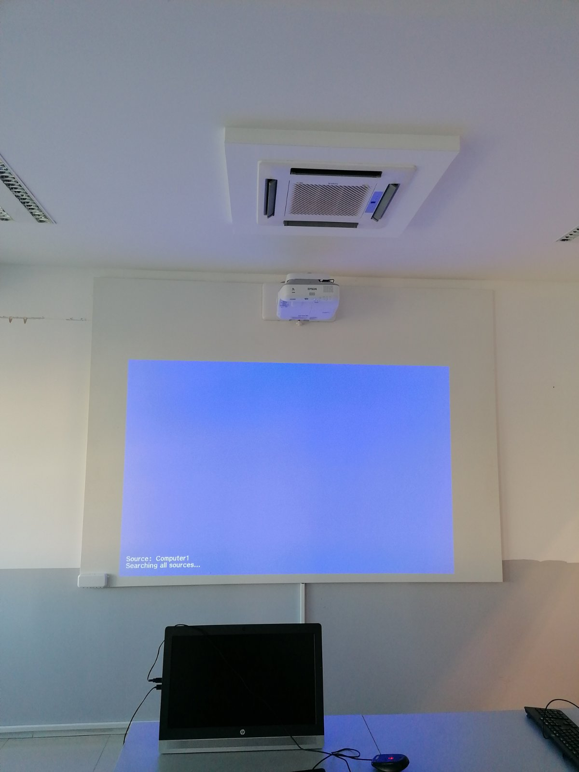
University Mediterranean
The second part of the installation of the equipment for all three universities is prolonged following the situation in the COVID-19 outbreak at the world level. More precisely, the supplier sent the notification of equipment manufacturers on 27/10/2020 about delivery delays to the Commission nominated for the procurement of equipment for supporting internationalization and project staff about the reasons for it providing the Force majeure explanation about the mentioned.
The final minutes of the installment of the equipment will be issued by the Commission upon completing the first project year. The equipment will be ready for use in the second semester of the academic 2020/21.
The promotion of the equipment will be done in December 2020.

